**MID-TERM PROJECT**

**QUESTION-1**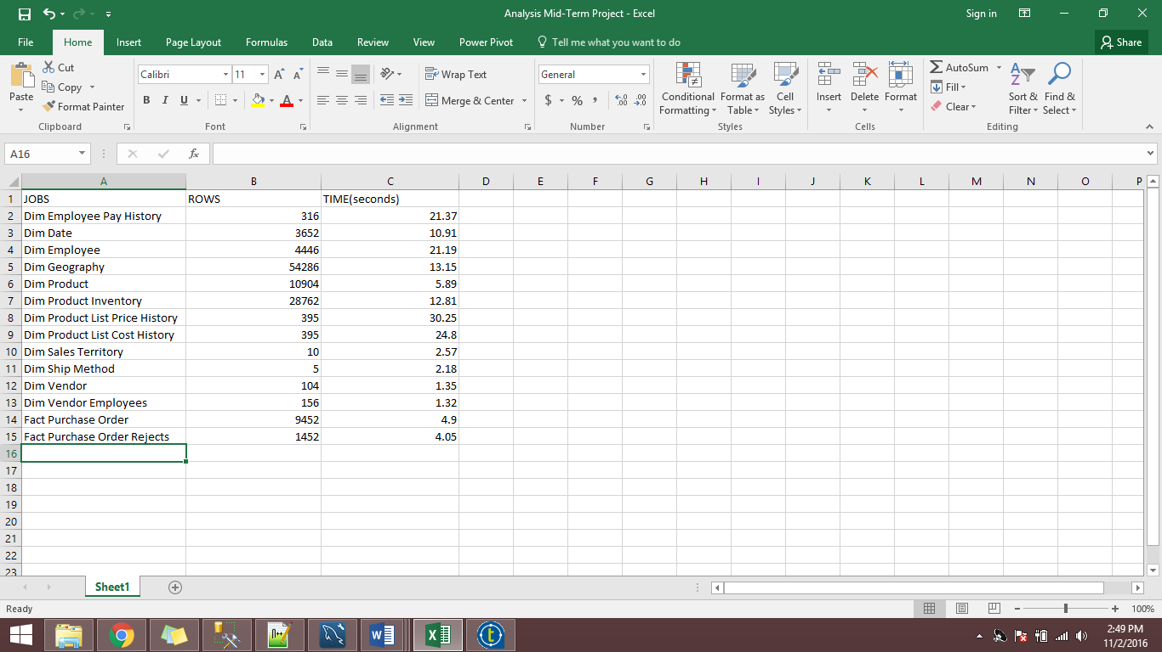

**QUESTION-2**

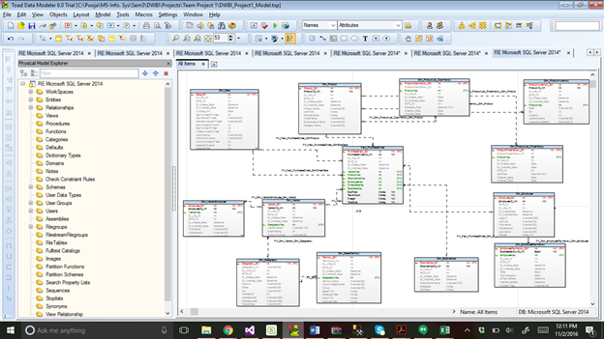

**QUESTION-3(TALEND)**

1. **DIM EMPLOYEE PAY HISTORY**

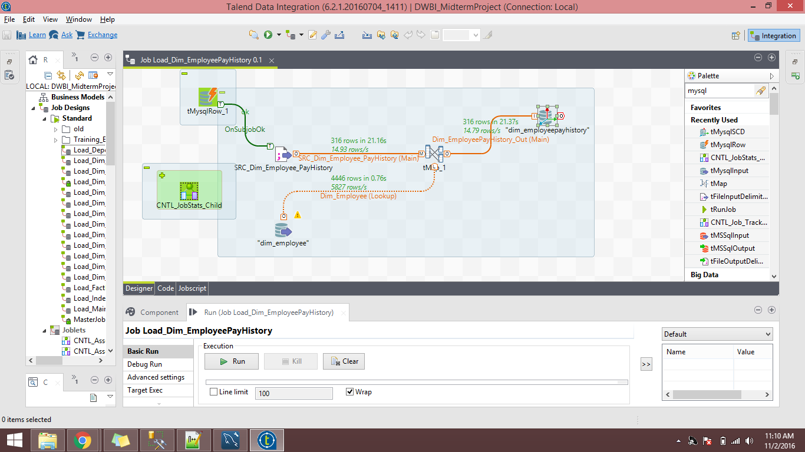

1. **DIM-DATE**

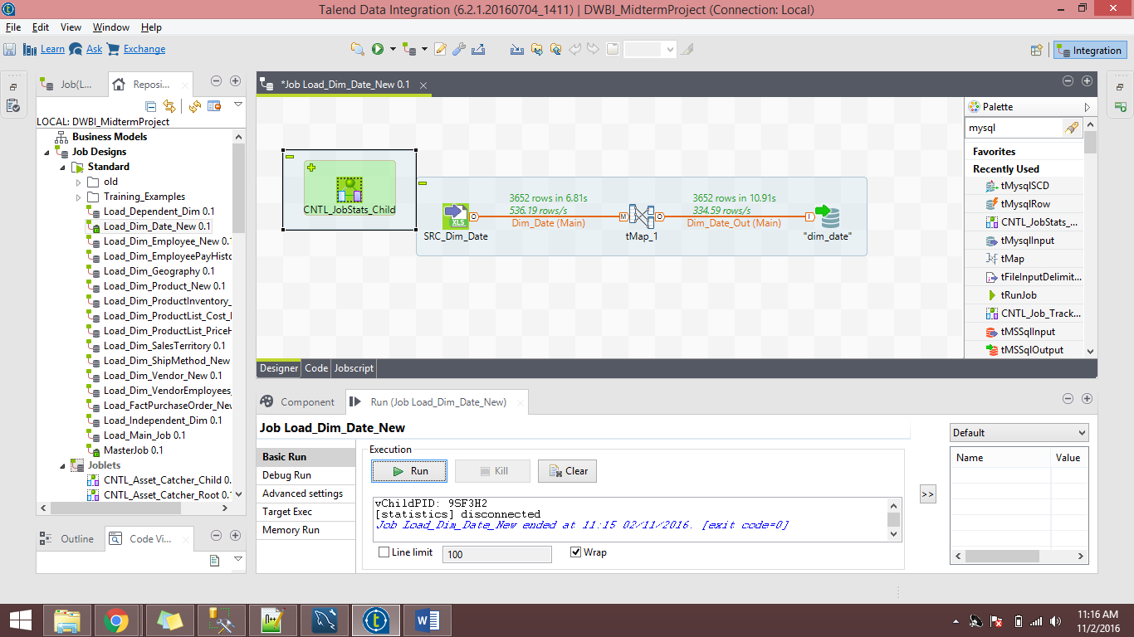

1. **DIM EMPLOYEE**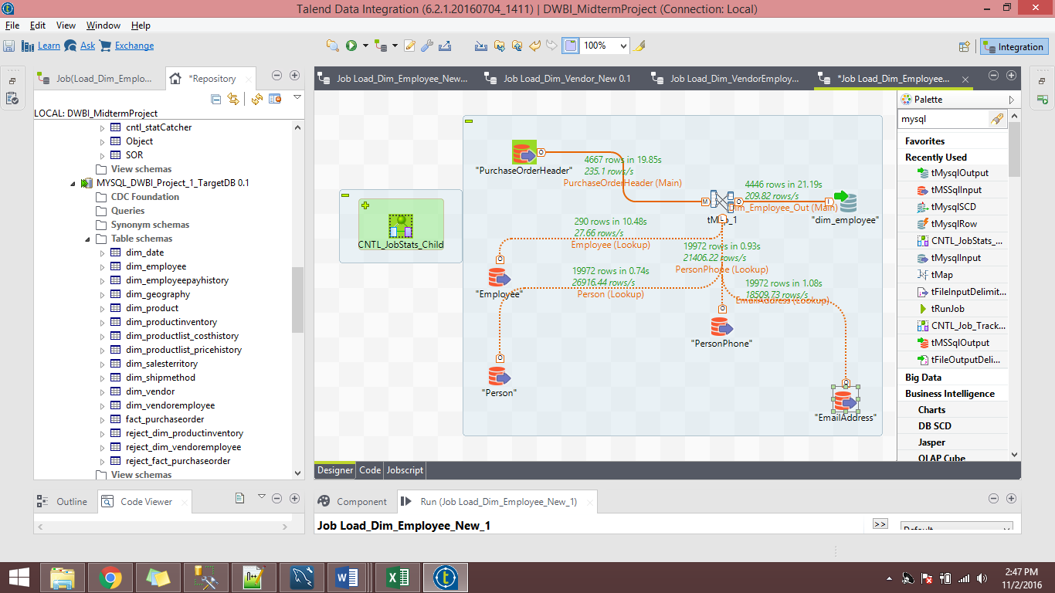
2. **DIM GEOGRAPHY**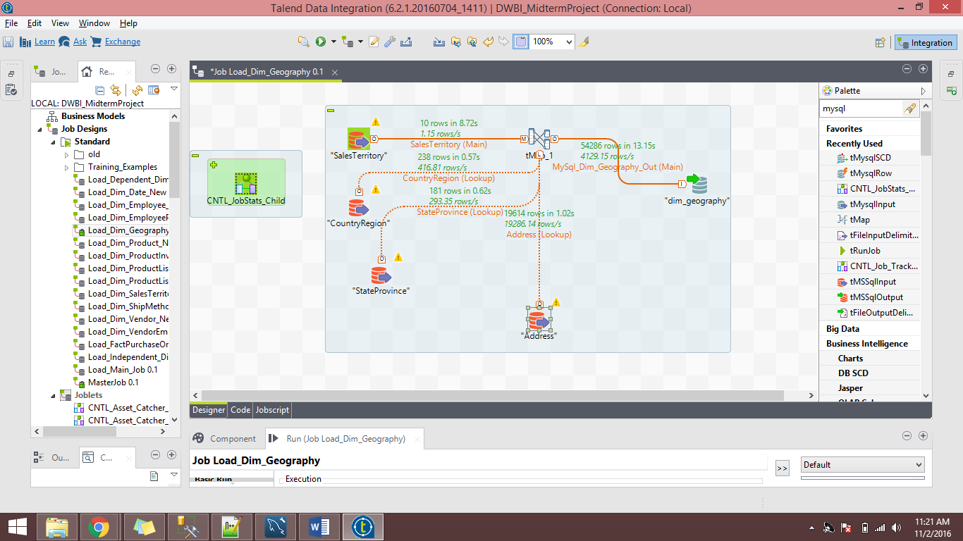
3. **DIM PRODUCT**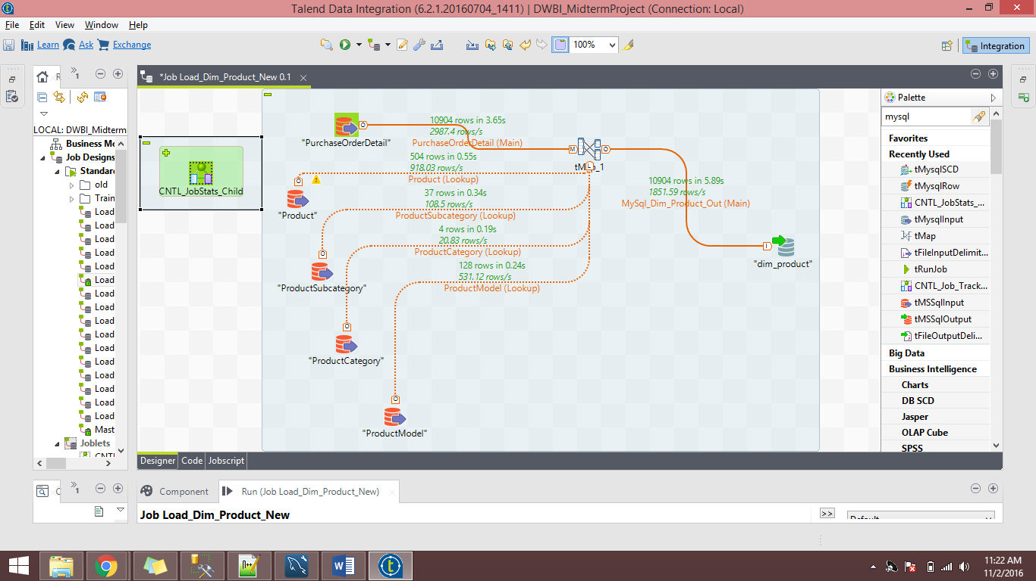
4. **DIM PRODUCT INVENTORY**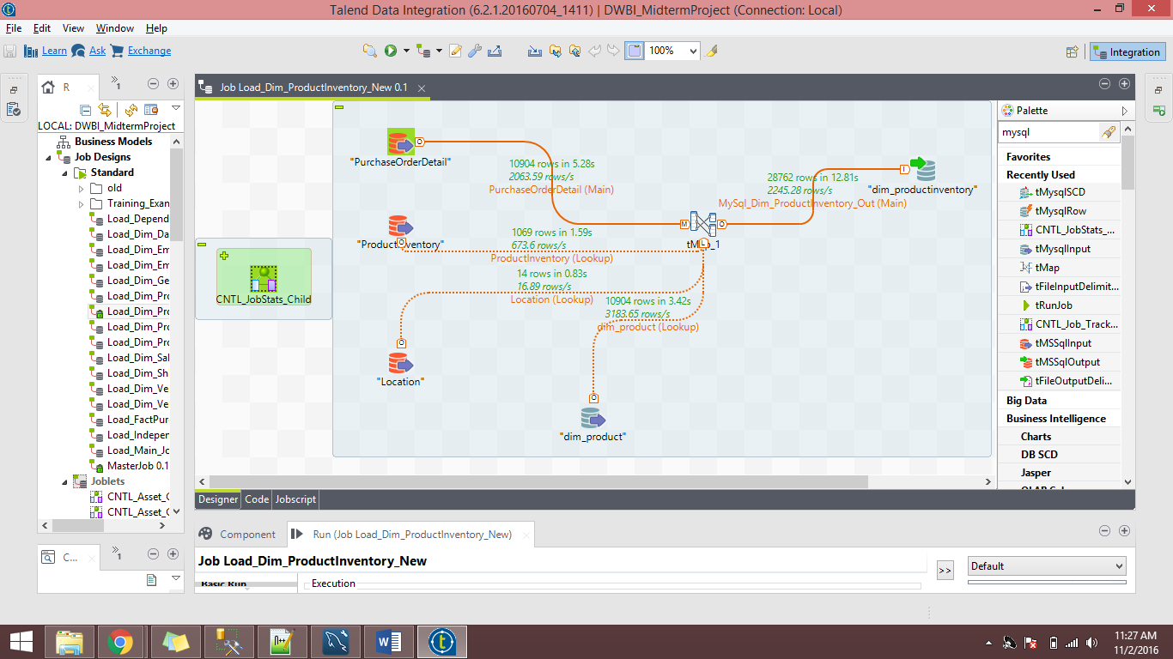
5. **DIM PRODUCT-LIST PRICE HISTORY**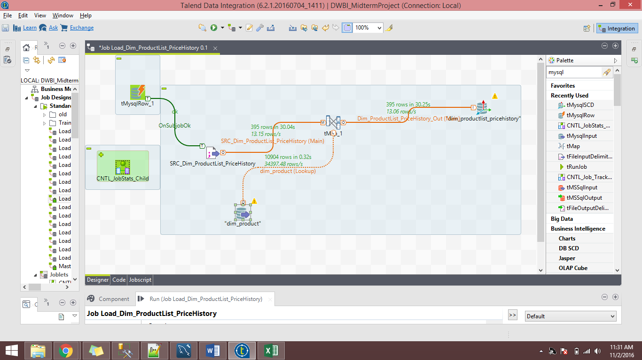
6. **DIM PRODUCT-LIST COST HISTORY**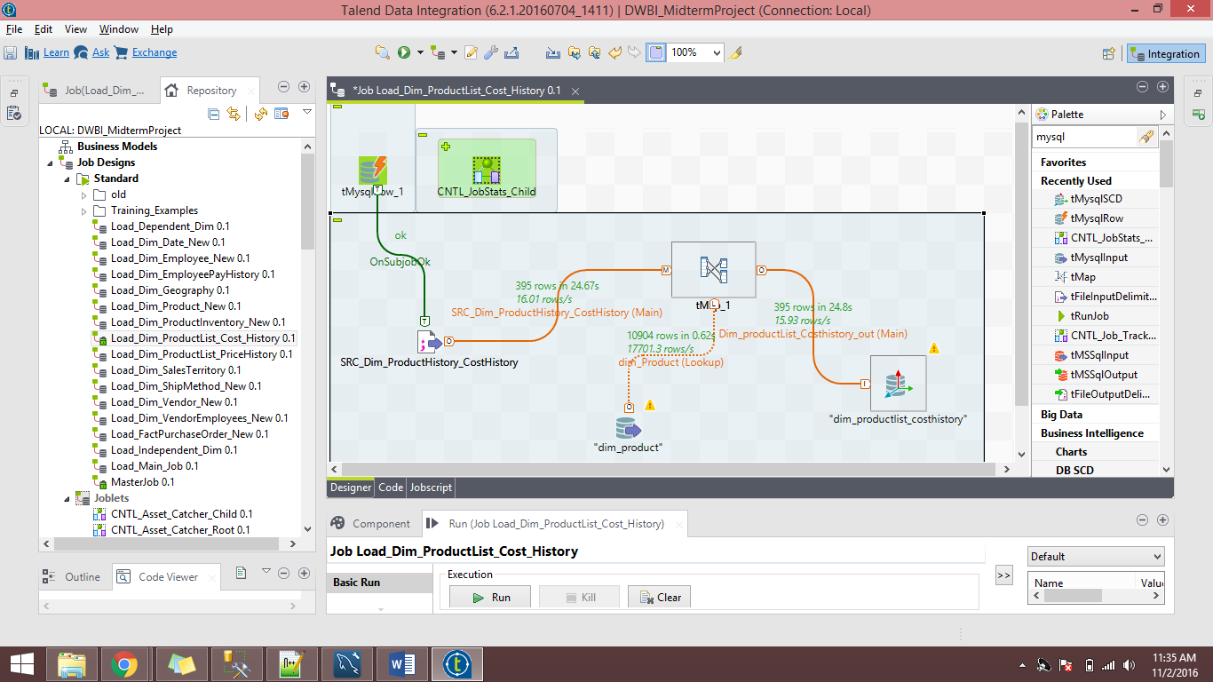
7. **DIM SALES TERRITORY**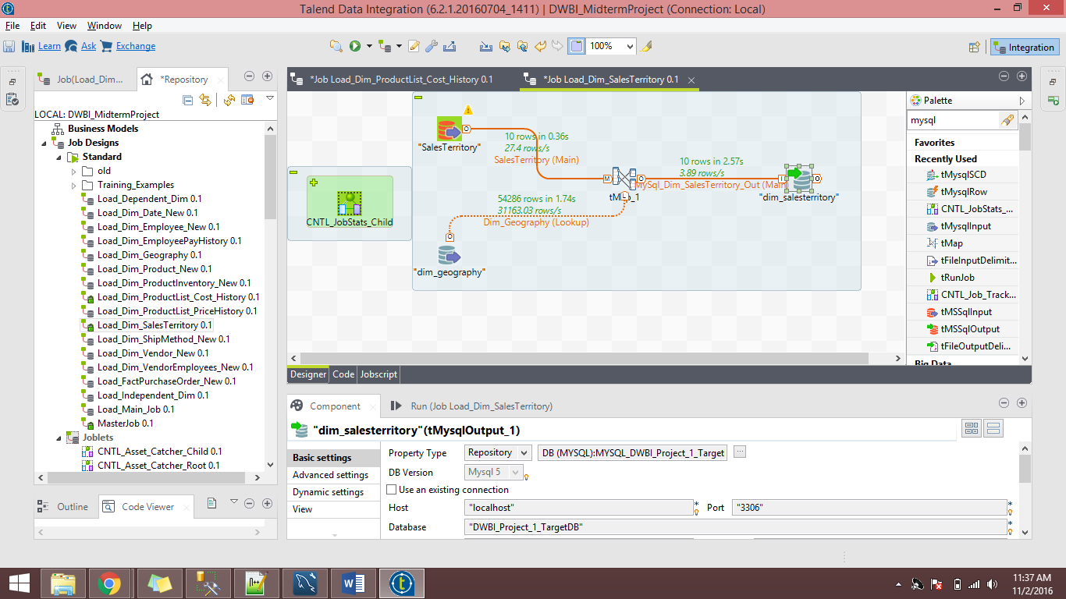
8. **DIM SHIP-METHOD**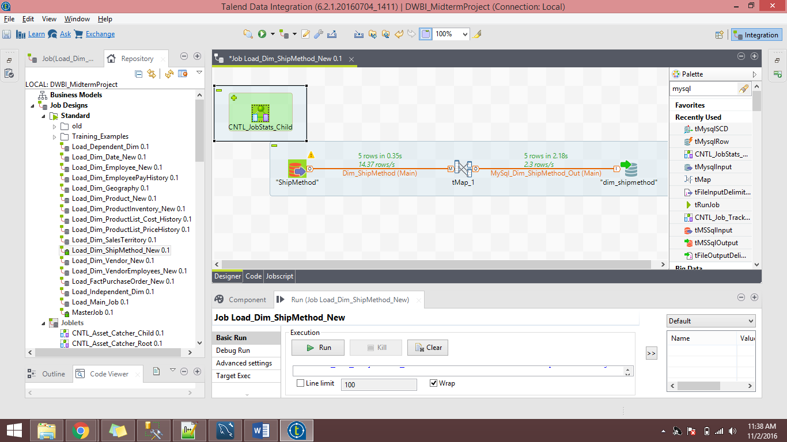
9. **DIM VENDOR**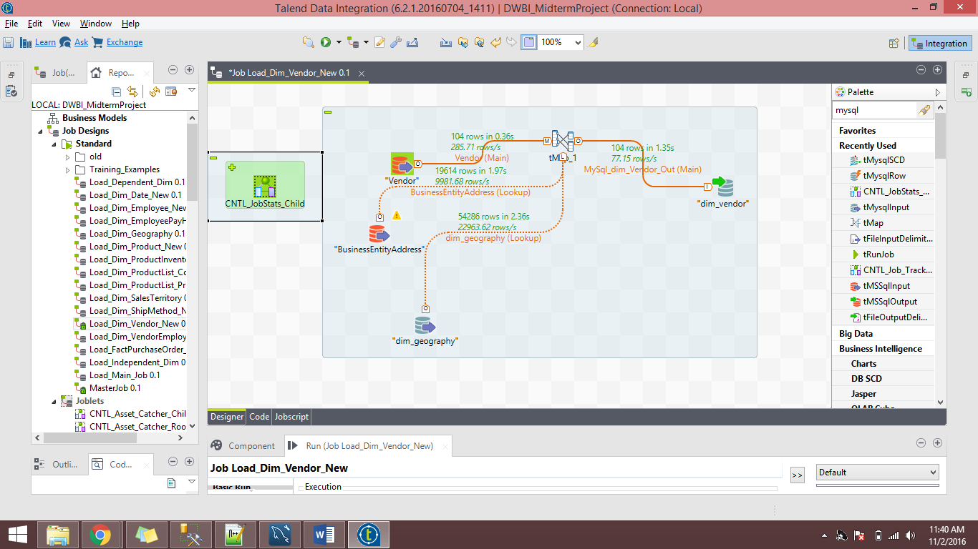
10. **DIM VENDOR-EMPLOYEES**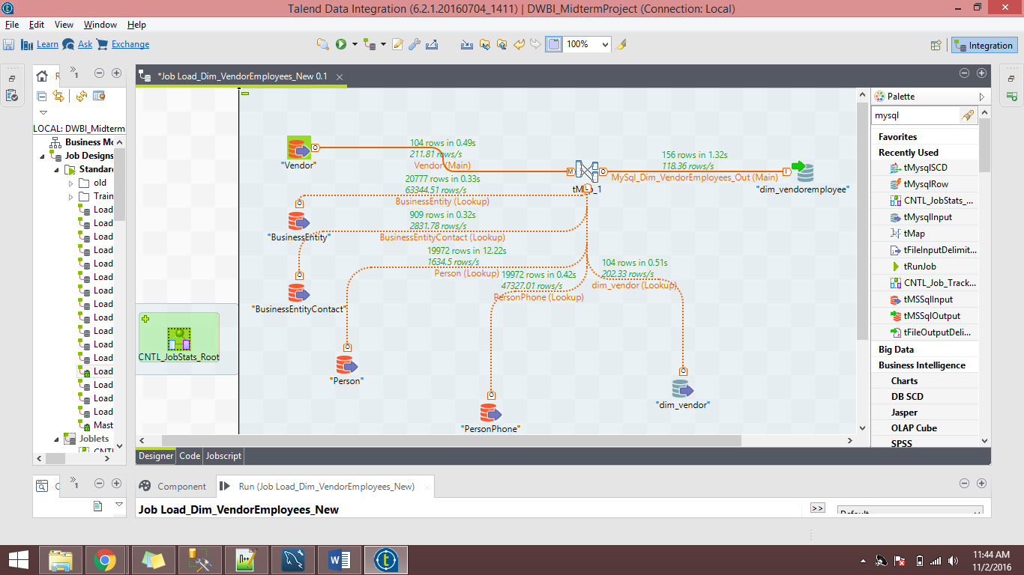
11. **FACT PURCHASE ORDER**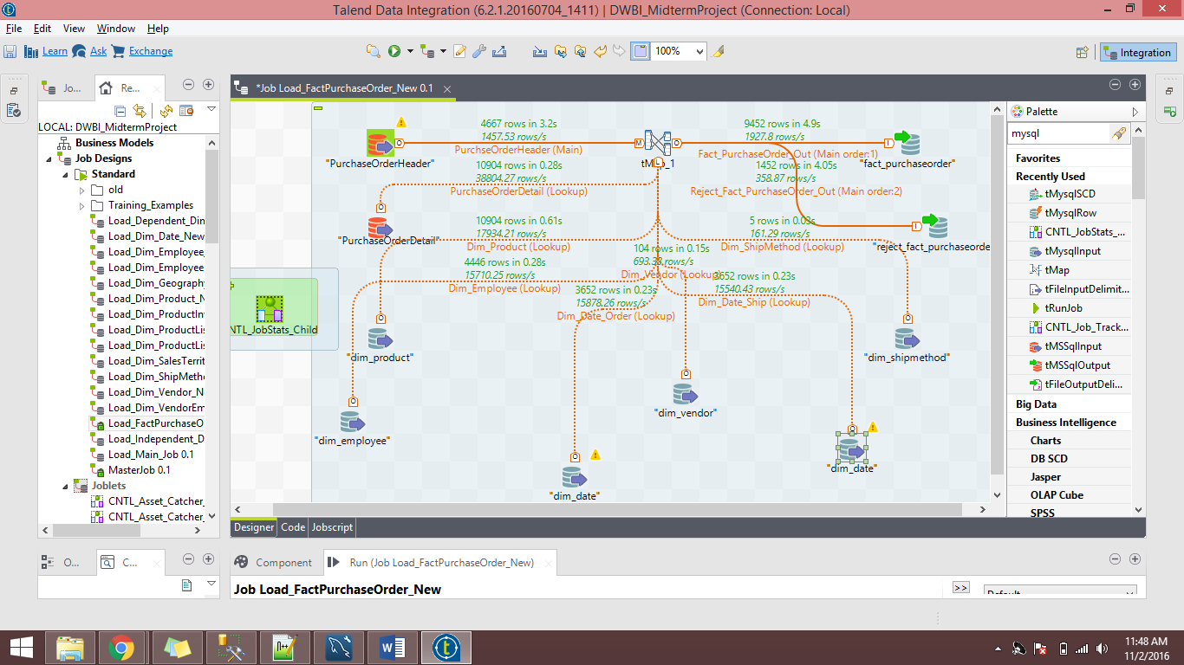
12. **INDEPENDENT DIMENSIONS**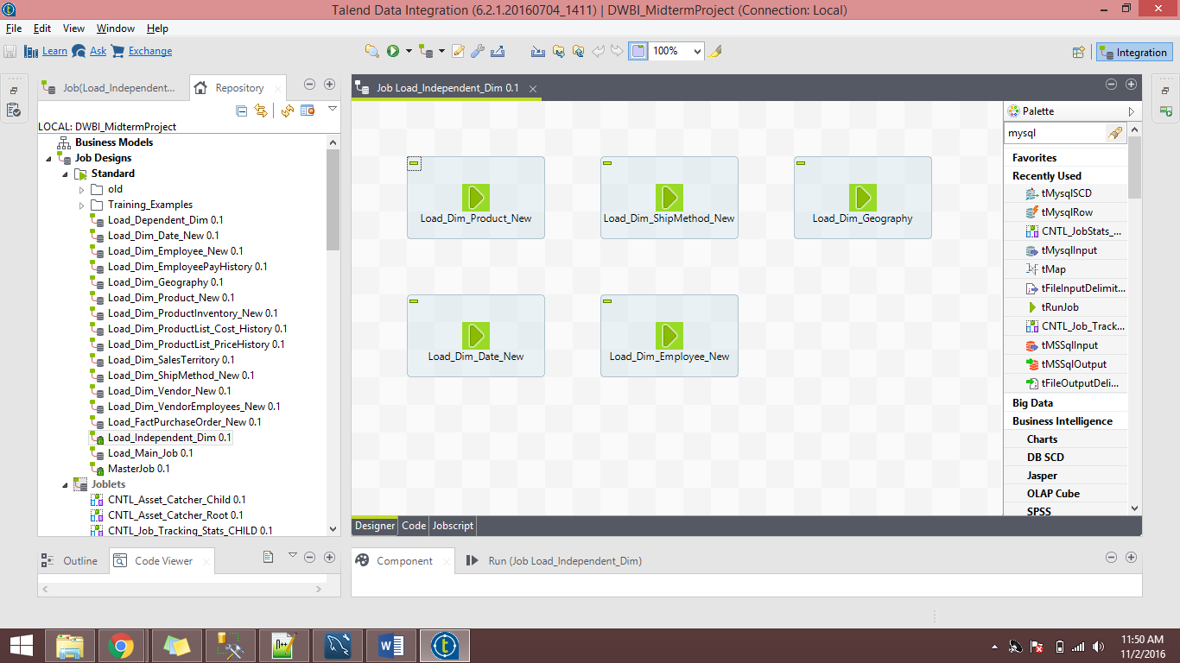
13. **DEPENDENT DIMENSIONS**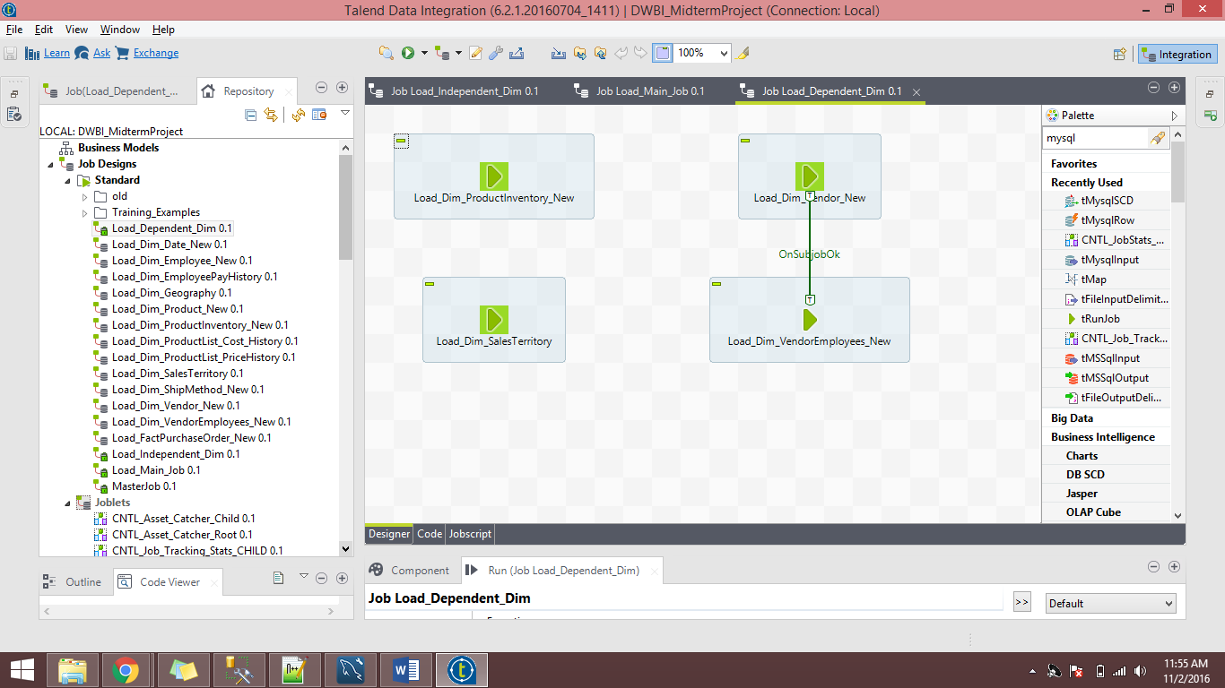
14. **MAIN JOB**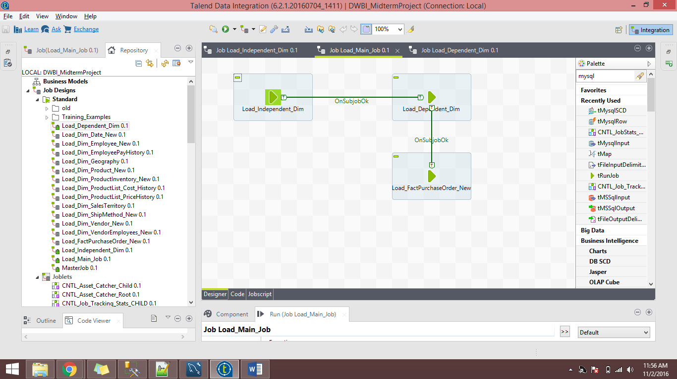

**QUESTION-3(SSIS)**

**1) Main Job:**

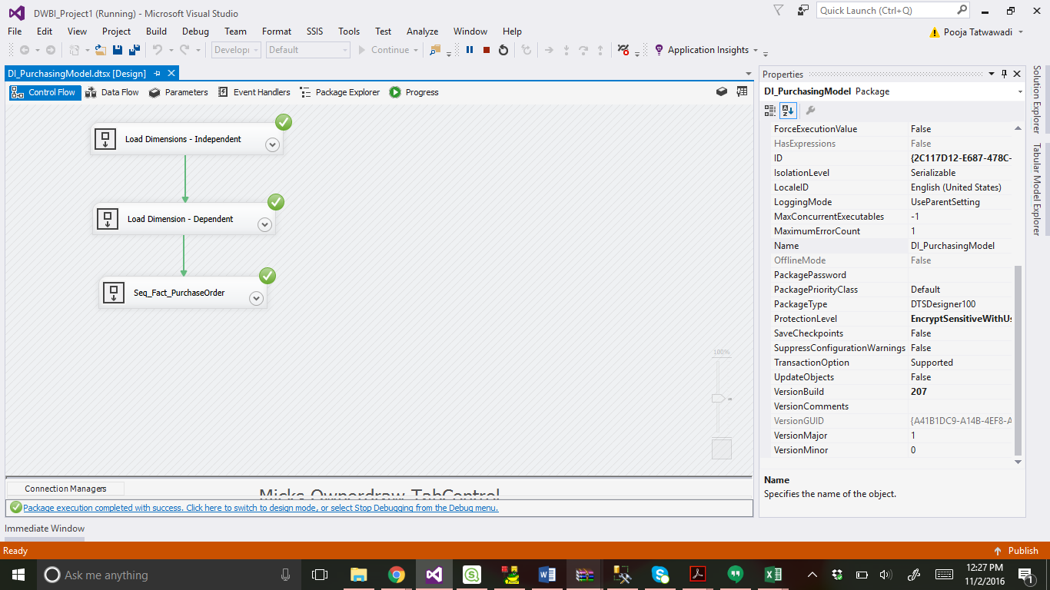

**Independent Dimensions:**

**1) Dim_Product**

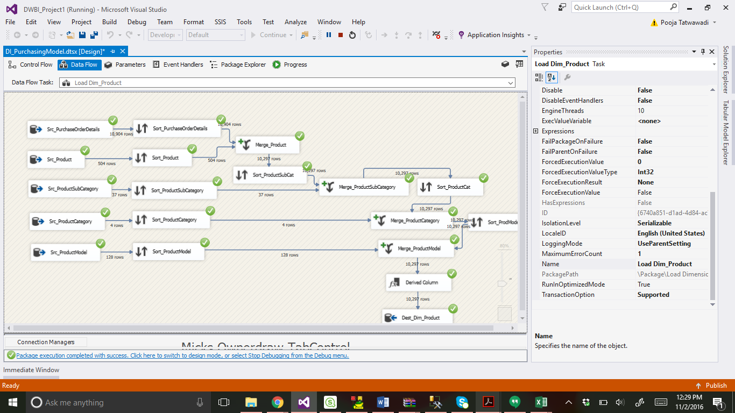

**2) Dim_Date**

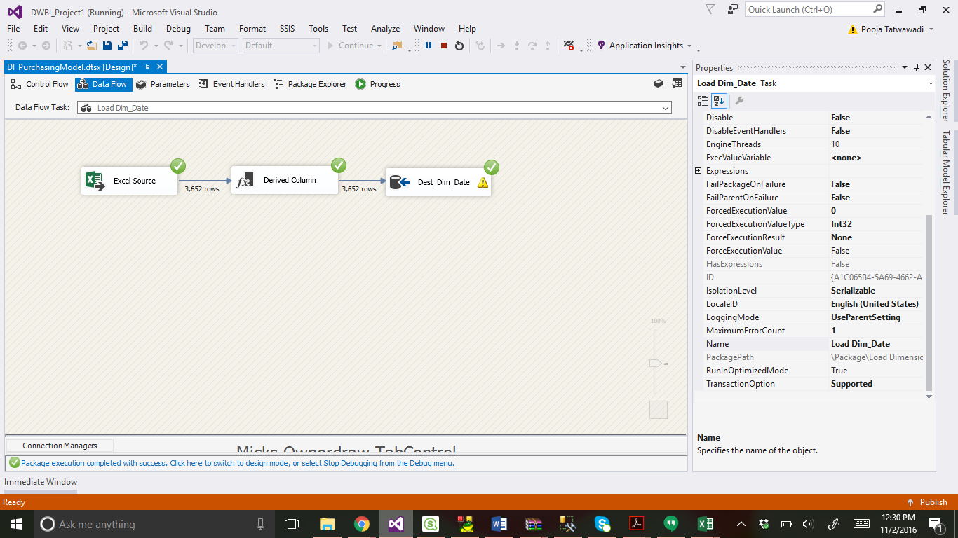

**3) Dim_ShipMethod**

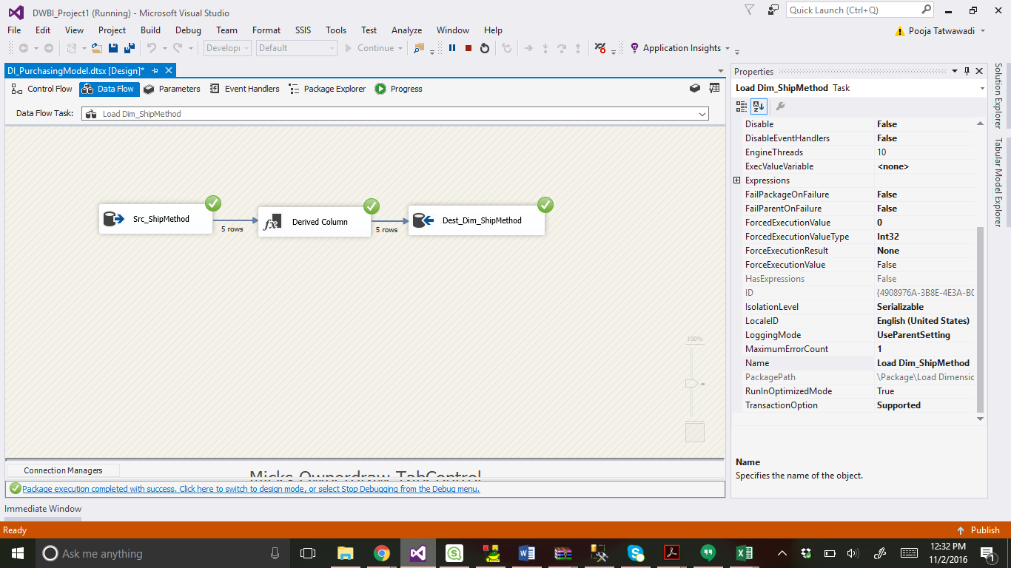

**4) Dim_Employee**

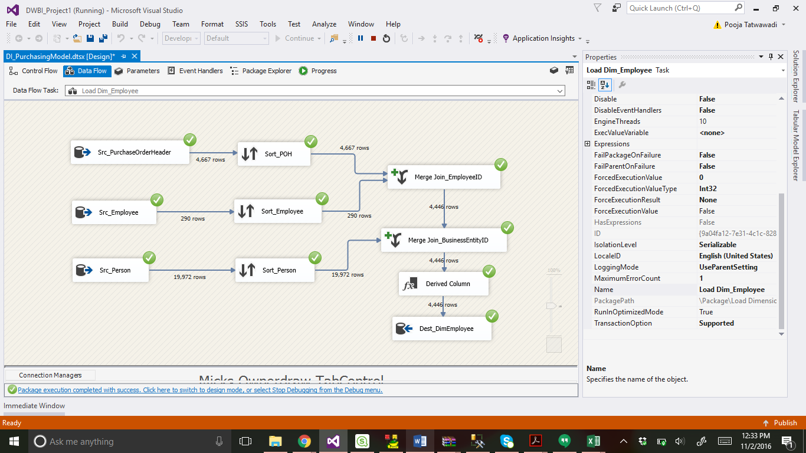

**5) Dim_Geography**

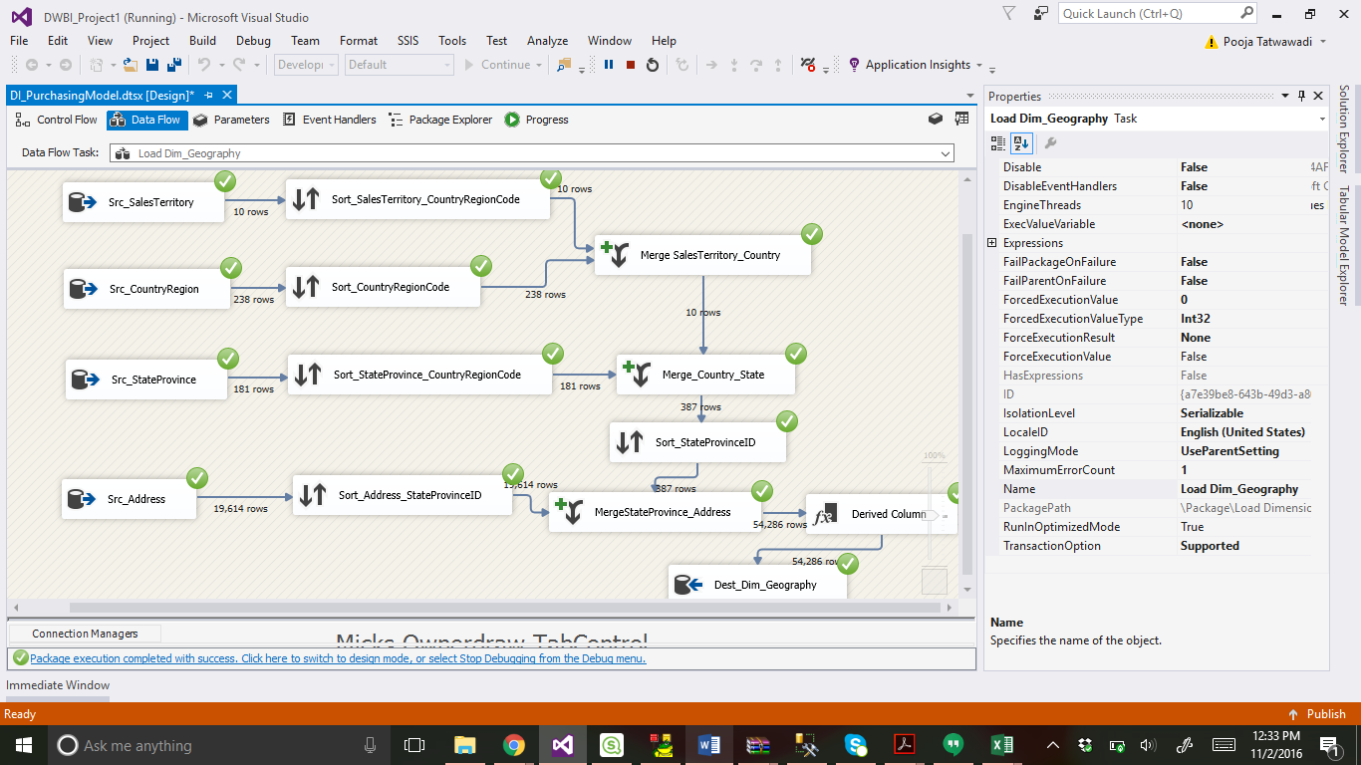

**Dependent Dimensions:**

**1) Dim_ProductInventory**

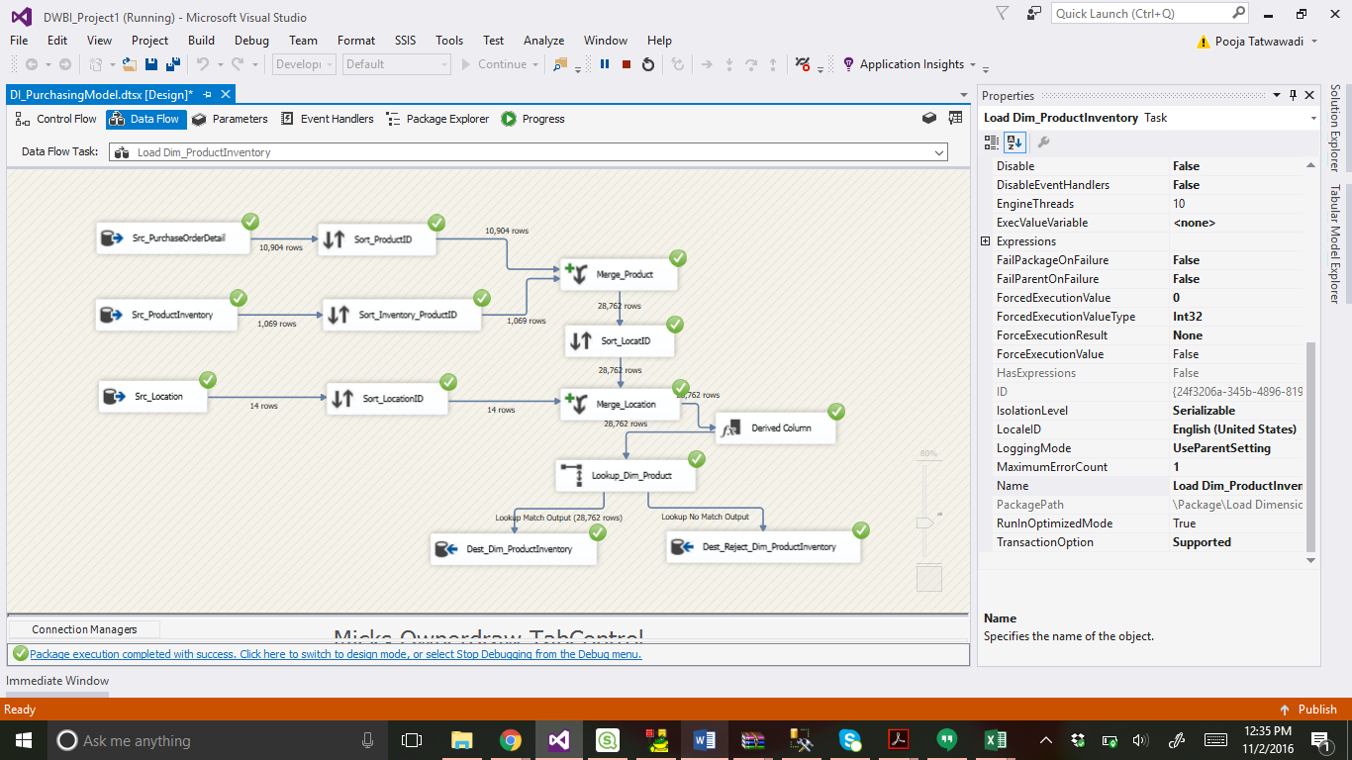

**2) Dim_Vendor**

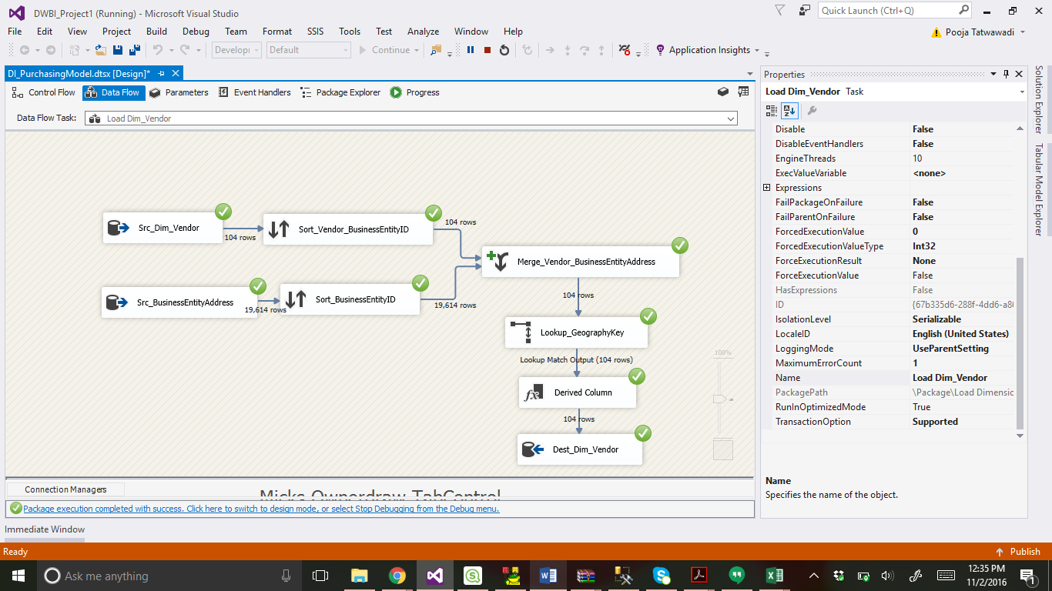

**3) Dim_VendorEmployee**

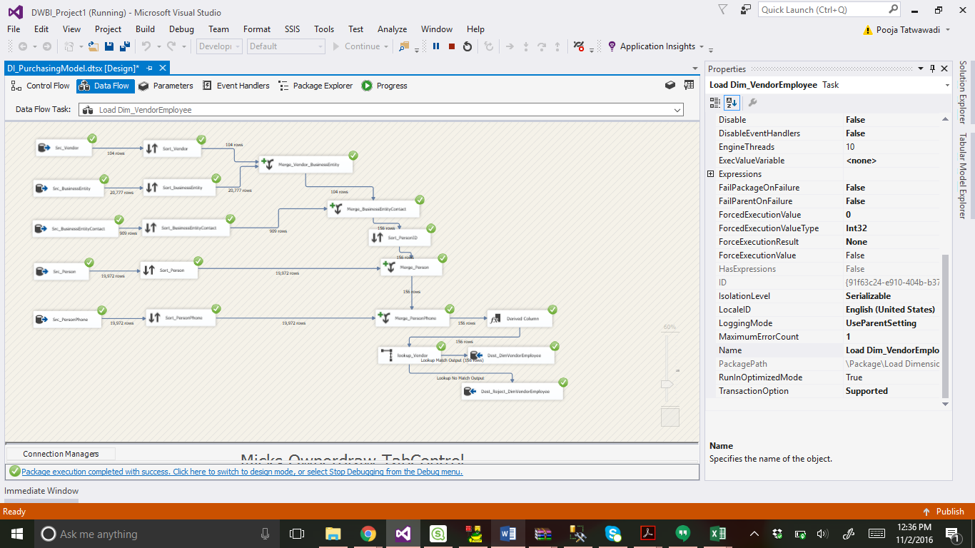

**4) Dim_SalesTerritory**

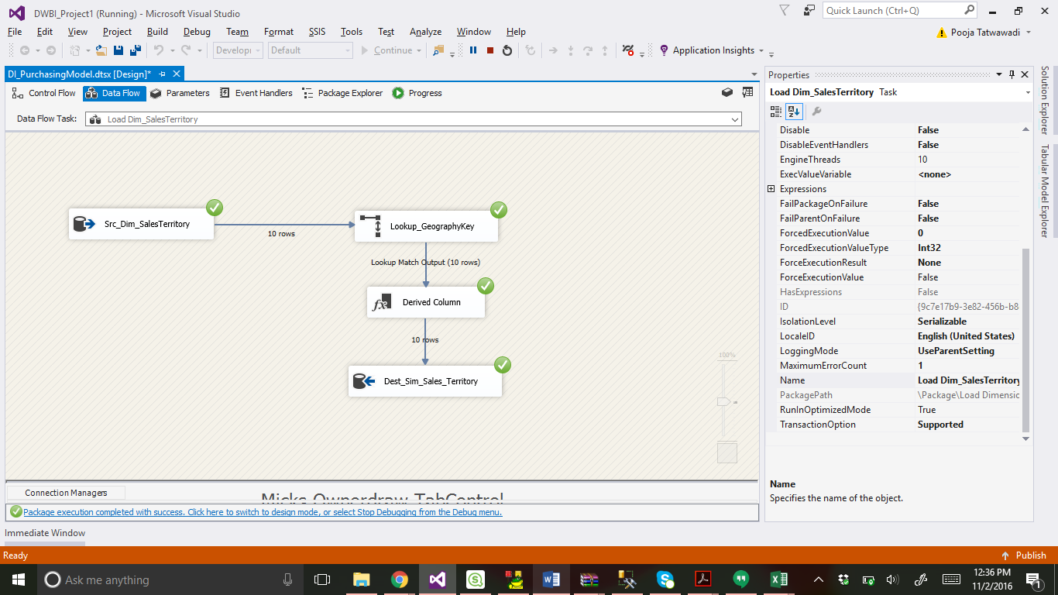

**5) SCD: Dim_ProductList_CostHistory_1**

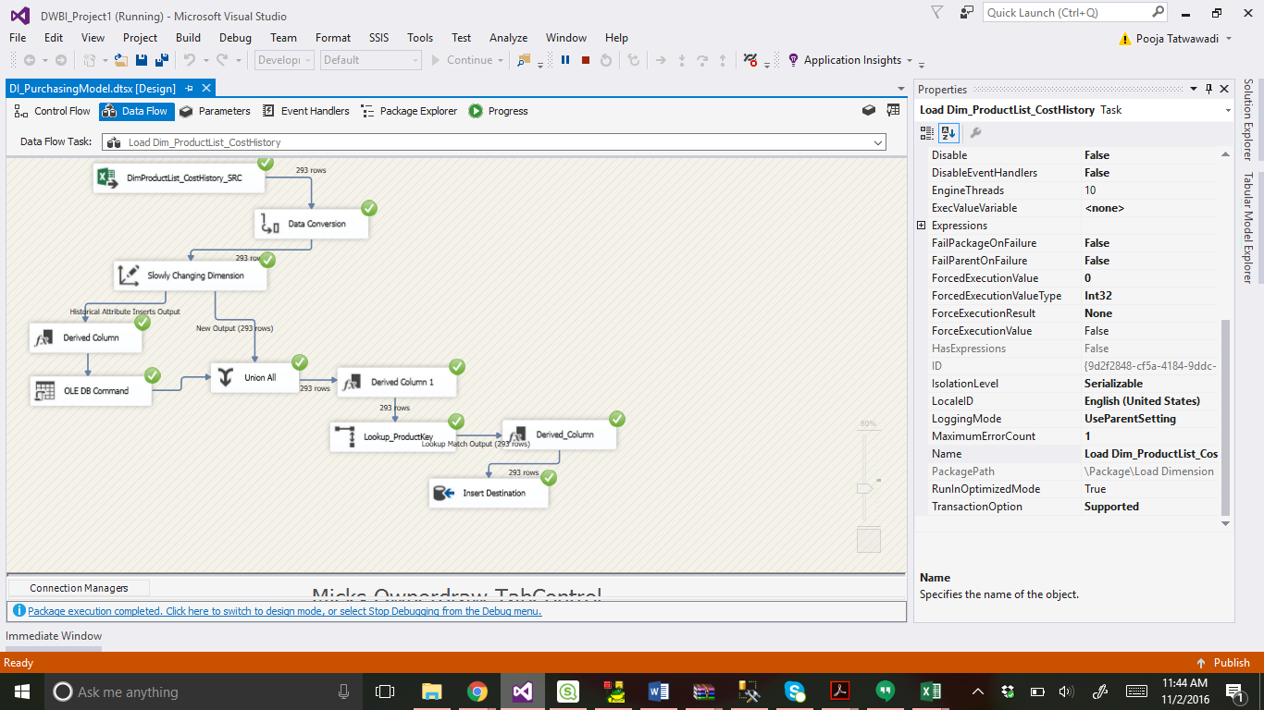

**Dim_ProductList_CostHistory_2**

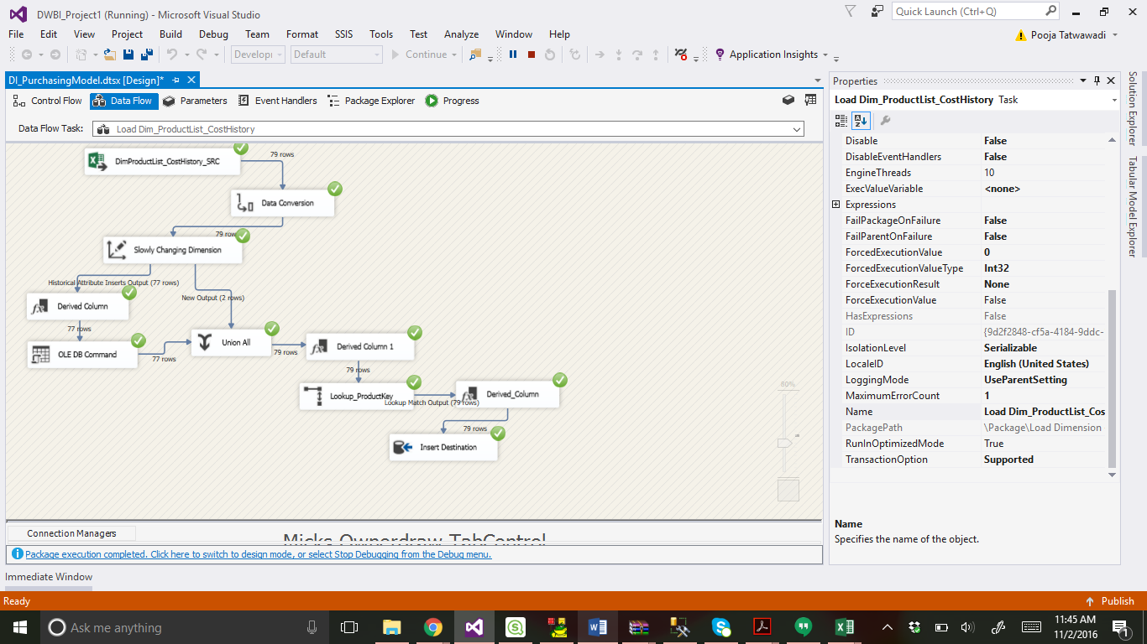

**Dim_ProductList_CostHistory_3**

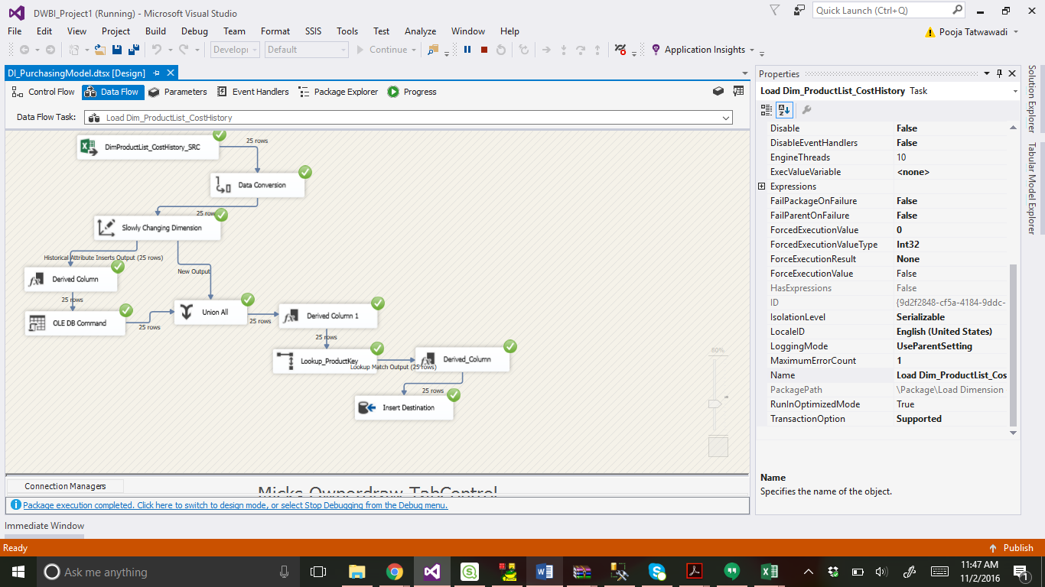

**6) Dim_Employee_PayHistory_1**

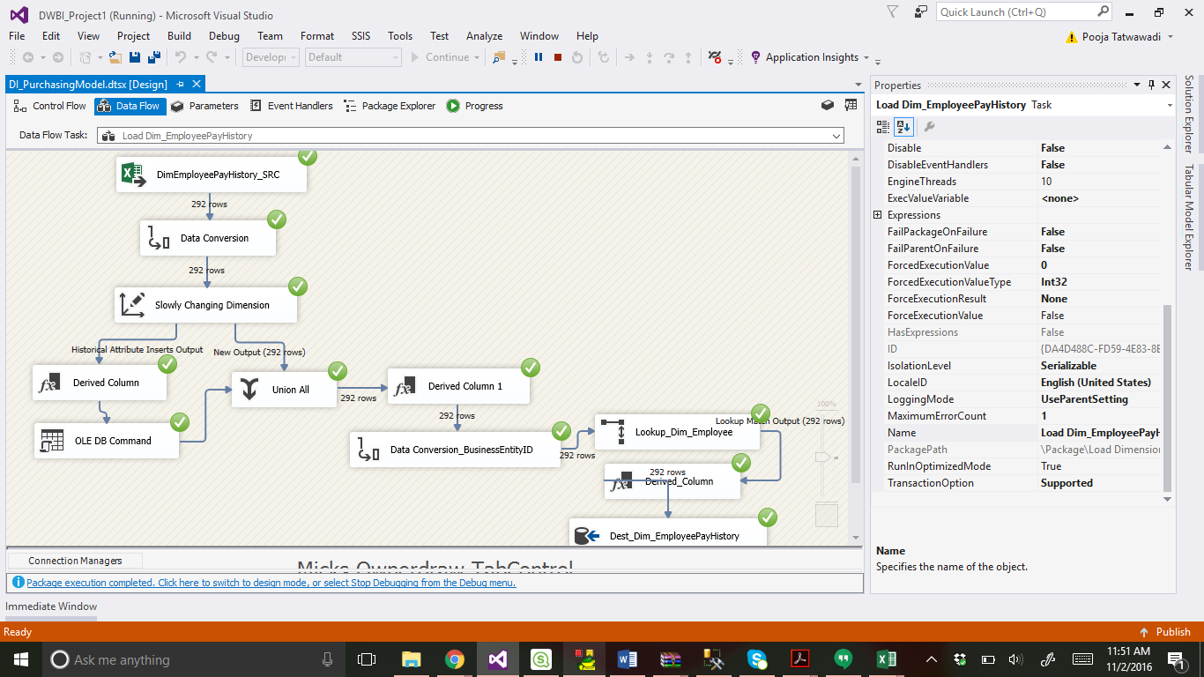

**Dim_Employee_PayHistory_2**

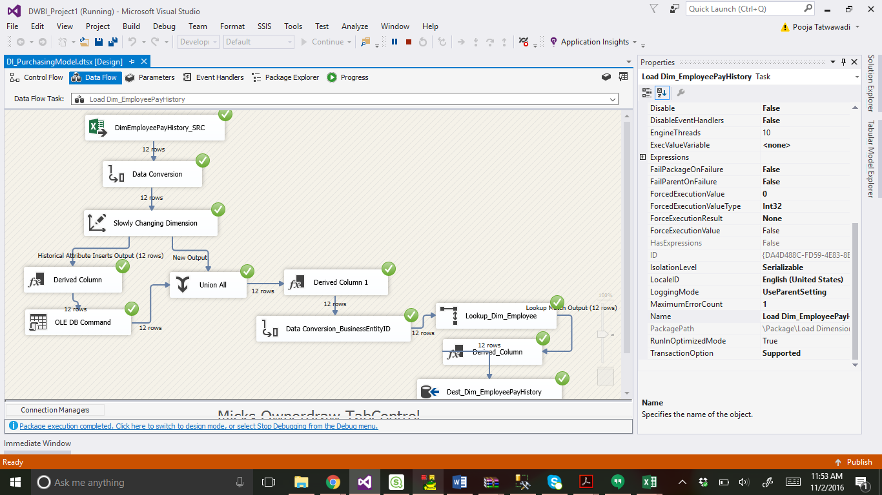

**Dim_Employee_PayHistory_3**

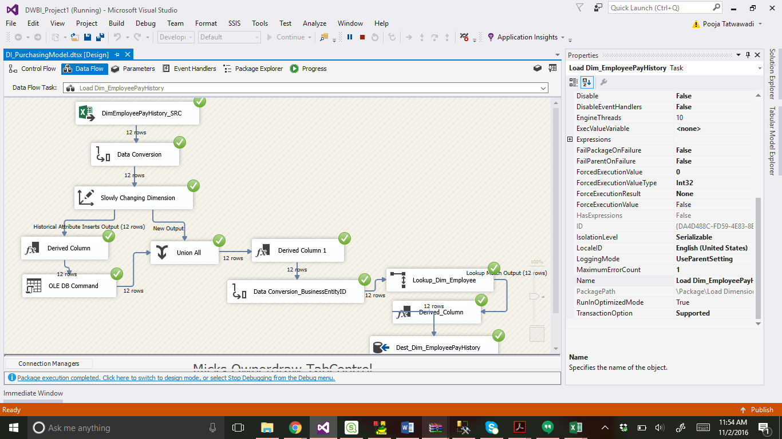

**7) SCD: ProductList_PriceHistory_1**

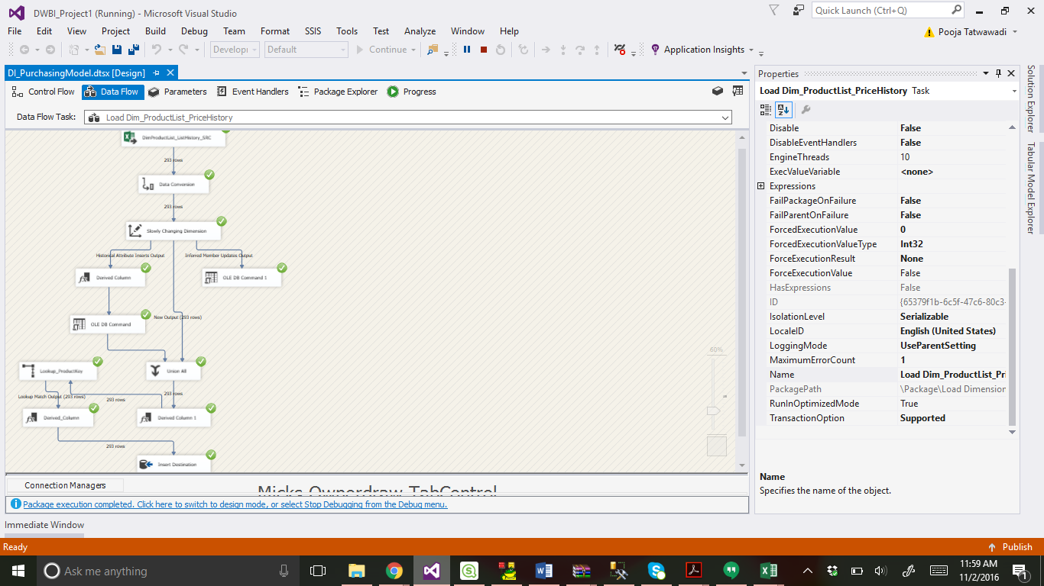

**ProductList_PriceHistory_2**

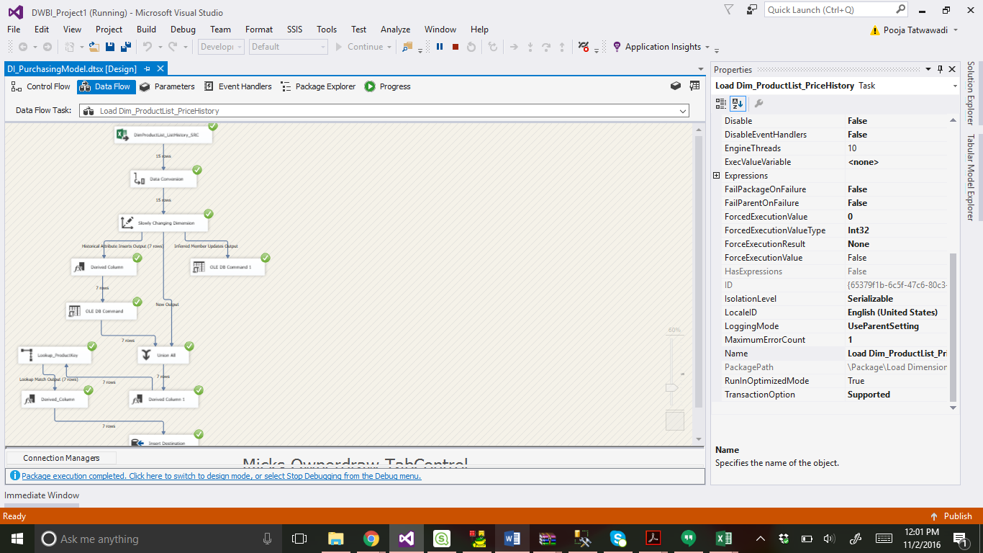

**ProductList_PriceHistory_3**

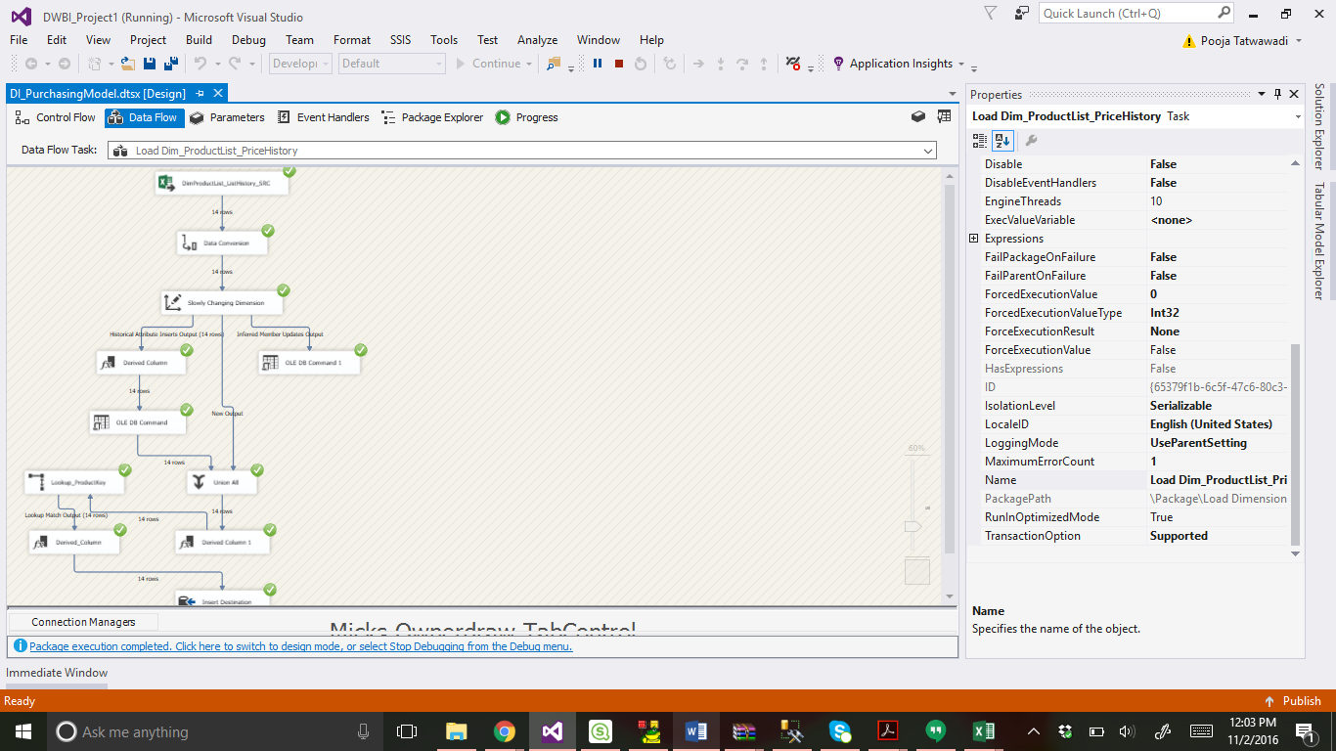

**FactTable-PurchaseOrder**

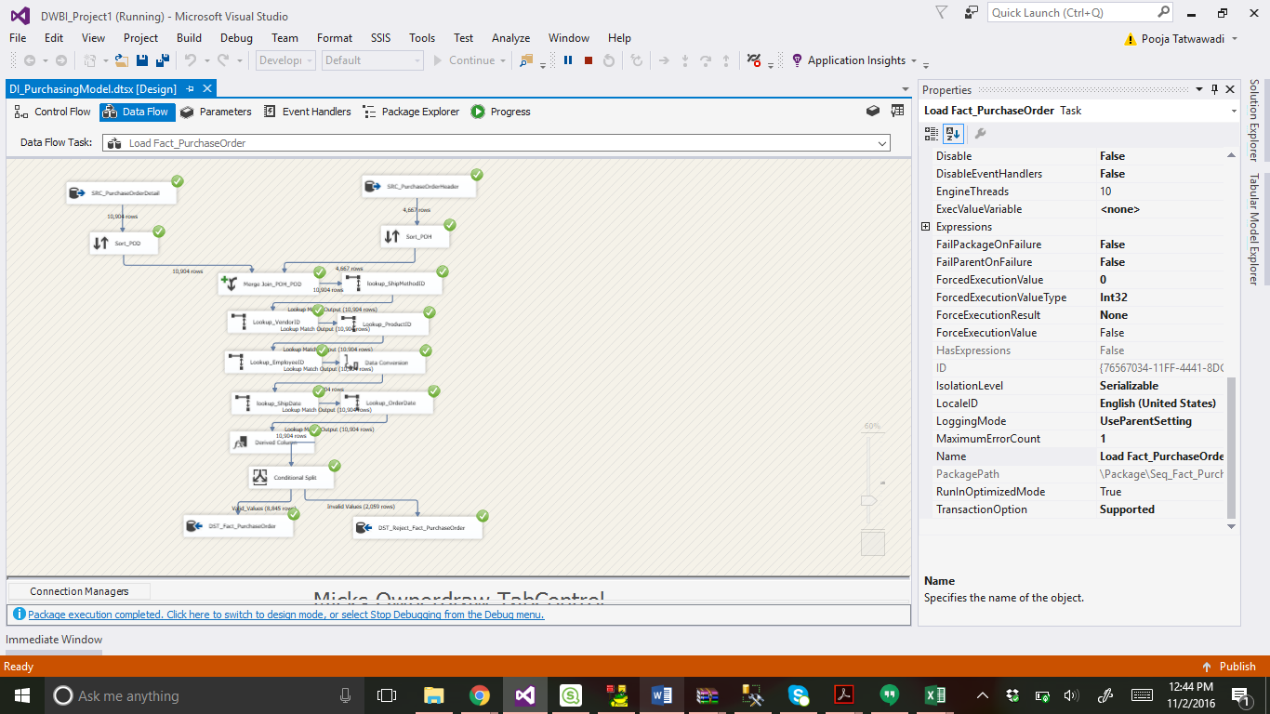

**QUESTION-4**

**Performance Statistics of Talend Load**

**QUESTION-5**

1) Data Integration rejection records

* Number of selected rows : 8845

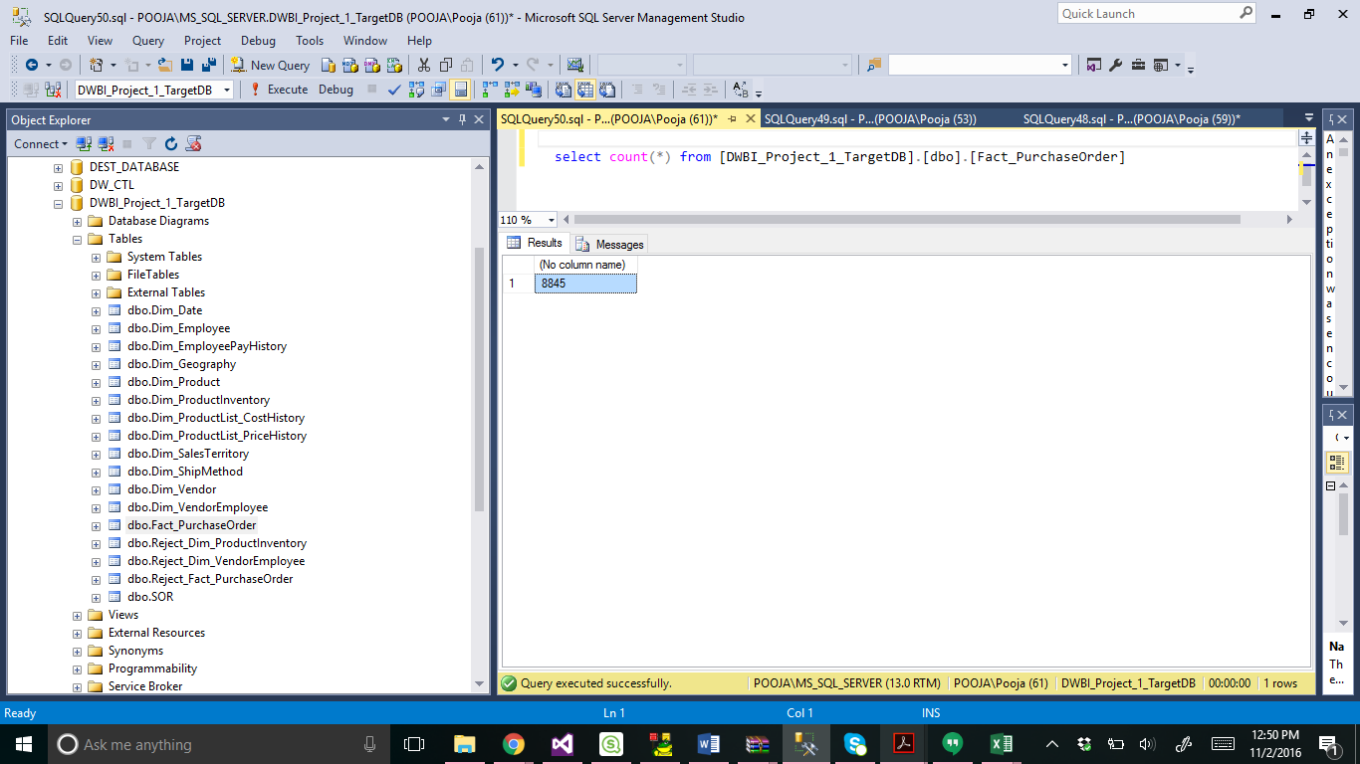

* Number of rejected rows: 2059

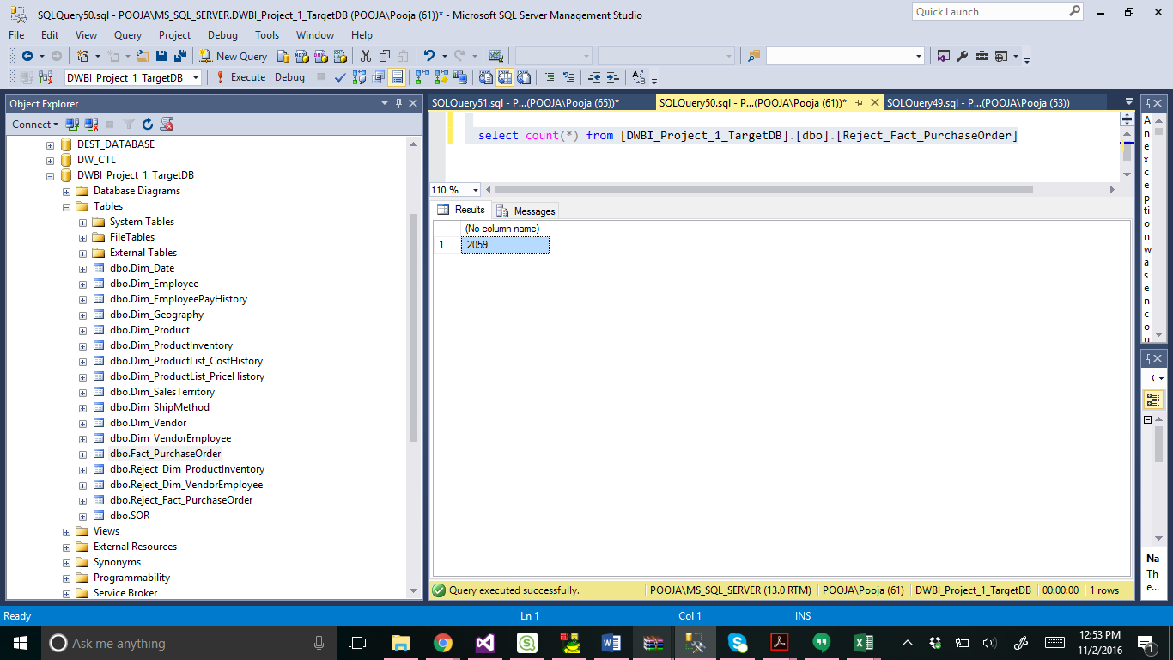

* Number or rows by rejection reason:

1. Due to Dim_Product: 607

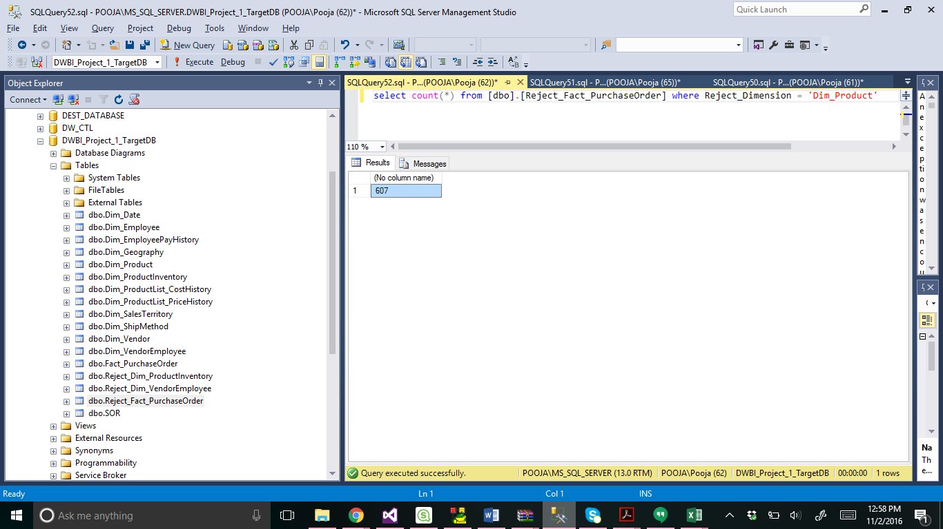

1. Due to Dim_ShipMethod: 645

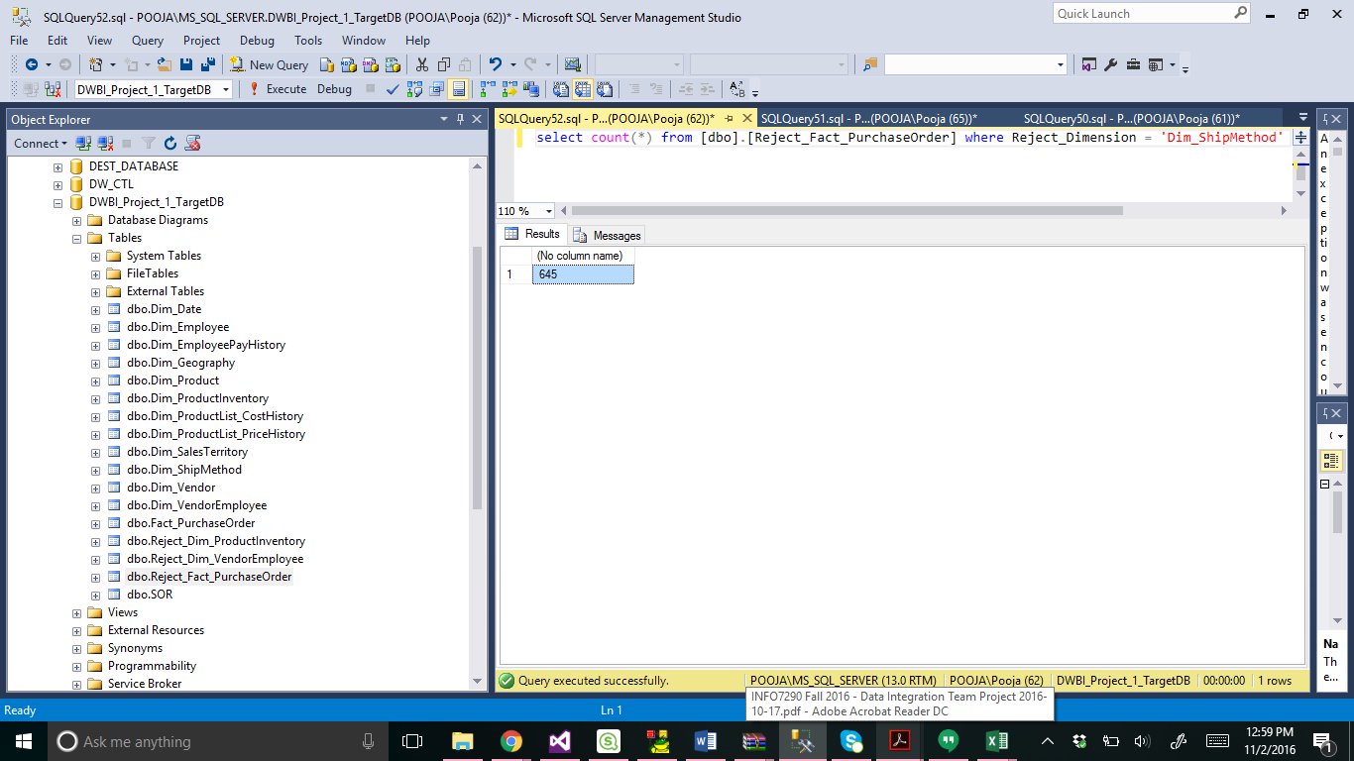

1. Due to Dim_Employee: 505

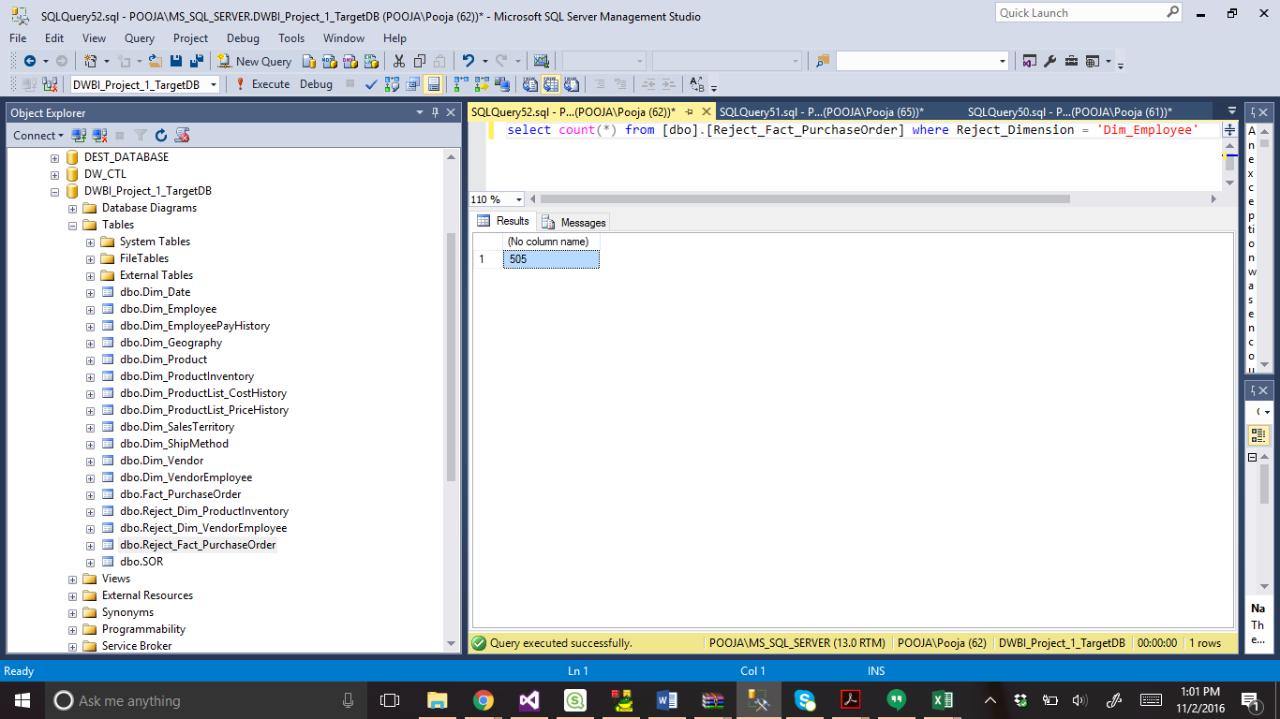

1. Due to Dim_Vendor: 302

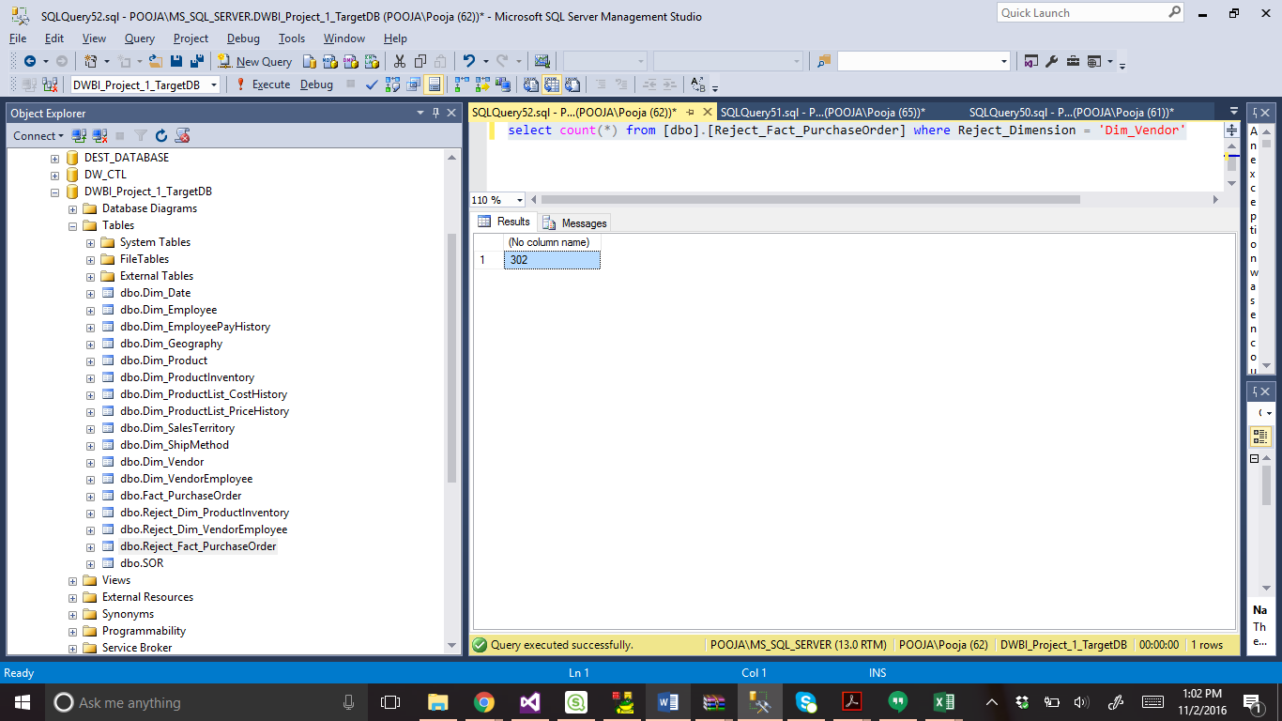

2) Ranked Order of vendors by purchase amount

SELECT *Sum*(fact_purchaseorder.totaldue)

TotalPurchase,   
       dim_vendor.vendorid_nk,   
       dim_vendor.vendorname,   
       dim_vendor.accountnumber,   
       **Dense_rank**()   
         OVER (   
           ORDER BY *Sum*(fact_purchaseorder.totaldue) DESC) AS Rank   
FROM   fact_purchaseorder   
       INNER JOIN dim_vendor   
               ON fact_purchaseorder.vendorkey = dim_vendor.vendor_sk   
GROUP  BY vendorid_nk,   
          dim_vendor.vendorname,   
          dim_vendor.accountnumber

3) Ranked Order of Product purchase by amount

* By Product Category

SELECT *Sum*(fact_purchaseorder.totaldue)                    AS TotalPurchase,   
       dim_product.categoryname,   
       **Dense_rank**()   
         OVER (   
           ORDER BY *Sum*(fact_purchaseorder.totaldue) DESC) AS Rank   
FROM   fact_purchaseorder   
       INNER JOIN dim_product   
               ON fact_purchaseorder.productkey = dim_product.product_sk   
GROUP  BY dim_product.categoryname   
HAVING dim_product.categoryname IS NOT NULL

* By Product SubCategory

SELECT *Sum*(fact_purchaseorder.totaldue)                    AS TotalPurchase,   
       dim_product.subcategoryname,   
       **Dense_rank**()   
         OVER (   
           ORDER BY *Sum*(fact_purchaseorder.totaldue) DESC) AS Rank   
FROM   fact_purchaseorder   
       INNER JOIN dim_product   
               ON fact_purchaseorder.productkey = dim_product.product_sk   
GROUP  BY dim_product.subcategoryname   
HAVING dim_product.subcategoryname IS NOT NULL

* By Product Model

SELECT TOP (20) *Sum*(fact_purchaseorder.totaldue)   
                Totalpurchase,   
                dim_product.modelname,   
                **Dense_rank**()   
                  OVER (   
                    ORDER BY *Sum*(fact_purchaseorder.totaldue) DESC) AS Rank   
FROM   fact_purchaseorder   
       INNER JOIN dim_product   
               ON fact_purchaseorder.productkey = dim_product.product_sk   
GROUP  BY dim_product.modelname   
HAVING dim_product.modelname IS NOT NULL

* By Product

SELECT TOP (20) *Sum*(fact_purchaseorder.totaldue)                    AS   
                Totalpurchase,   
                dim_product.productname,   
                dim_product.productid_nk,   
                **Dense_rank**()   
                  OVER (   
                    ORDER BY *Sum*(fact_purchaseorder.totaldue) DESC) AS Rank   
FROM   fact_purchaseorder   
       INNER JOIN dim_product   
               ON fact_purchaseorder.productkey = dim_product.product_sk   
GROUP  BY dim_product.productid_nk,   
          dim_product.productname

* List of employees who purchased products with phone and email

SELECT DISTINCT dim_employee.firstname,   
                dim_employee.middlename,   
                dim_employee.lastname,   
                dim_employee.gender,   
                dim_employee.phonenumber,   
                dim_employee.email   
FROM   fact_purchaseorder   
       INNER JOIN dim_employee   
               ON fact_purchaseorder.employeekey = dim_employee.employee_sk;

* List of Employees who purchased products with pay rate and raises (scd)

SELECT dim_employeepayhistory.rate,   
       dim_employeepayhistory.payfrequency,   
       dim_employee.firstname,   
       dim_employee.middlename,   
       dim_employee.lastname   
FROM   dim_employeepayhistory   
       INNER JOIN dim_employee   
               ON dim_employeepayhistory.employeekey = dim_employee.employee_sk

* List of Purchasing Vendor contacts with name and address

SELECT dim_vendor.vendorname,   
       dim_vendor.creditrating,   
       dim_vendor.accountnumber,   
       dim_geography.addressid,   
       dim_geography.city,   
       dim_geography.state,   
       dim_geography.country   
FROM   dim_vendor   
       INNER JOIN dim_geography   
               ON dim_vendor.geographykey = dim_geography.geography_sk   
WHERE  dim_vendor.vendorname != 'Unknown'

* List of prices by product order by product and SCD effective ascending

SELECT dim_productlist_pricehistory.listprice,   
       dim_productlist_pricehistory.start_date,   
       dim_productlist_pricehistory.current_flag   
FROM   dim_productlist_pricehistory   
       INNER JOIN dim_product   
               ON dim_productlist_pricehistory.productkey =   
                  dim_product.productid_nk   
ORDER  BY dim_product.productname,   
          dim_productlist_pricehistory.start_date ASC

* List of standard costs by product order by product and SCD effective ascending

SELECT dim_product.productname,

dim_productlist_costhistory.current_flag,

dim_productlist_costhistory.start_date,

dim_productlist_costhistory.standard_cost

FROM dim_productlist_costhistory

INNER JOIN dim_product

ON dim_productlist_costhistory.productkey =

dim_product.product_sk

ORDER BY dim_product.productname,

dim_productlist_costhistory.start_date